Impact of Music Type and Memory Task on Short-Term Memory Accuracy

STAT4220 – Applied Experimental Designs
Fall 2025

Abstract
This study examined the effects of two types of music (40 Hz gamma waves and pop music) and two types of memory tasks (image recall and word recall) on short-term memory accuracy. Using a blocked 2×2 factorial design with 14 participants, we recorded accuracy scores on each memory task under each music condition. Scores from the word recall task listening to 40 Hz gamma waves had the highest accuracy, while the image recall task listening to pop music scores were least accurate. A two-way blocked ANOVA indicated no significant interaction between music and task type, moderate evidence of a main effect of music, and weak evidence of a main effect of task. This report summarizes the methodology, results, and interpretation.

Background and Significance
Music is a major part of many people’s daily routines, especially when studying or trying to concentrate. College students often play music while working, but it’s unclear how different types of background music affect memory. Some music is advertised to improve concentration, while popular music may be distracting. For example, 40 Hz gamma-ray auditory stimulation has been linked to improved focus and working memory due to its potential influence on brainwave patterns. In contrast, pop music, with lyrics and varying rhythms, may divide attention. Although effects vary by person, this study investigates the average impact on college students. There are many forms of memory, such as visual and verbal, which rely on different cognitive pathways and may react differently to environmental factors like music. For instance, we hypothesize that lyrical pop music may interfere more with verbal memory than it does with visual memory.
This study aims to investigate how two types of music, pop and 40 Hz gamma stimulation, affect short-term memory performance on image and word recall tasks. Participants will complete both tasks under both music conditions, which allows us to compare performance within individuals. We hypothesize that memory performance will be higher with 40 Hz gamma ray stimulation than with pop music, and the image recall tasks will yield better performance than word-recall tasks. We also hypothesize that there will be a significant interaction between music type and type of memory task.

Method

Data Collection
Data was collected from fourteen undergraduate students. The sample consisted of college students enrolled in the STAT 4220 course, which provided a convenience sample. Each participant completed a Google form, which presented each treatment as a separate question. Each question’s instructions contained the assigned memory task (image or word) along with a link to the corresponding music track. For each question, participants viewed 12 items, either images or words, and were given 30 seconds to memorize them while listening to the assigned music at 50% volume. Immediately afterward, they completed a recall test and were given an accuracy score out of 12. The Google form randomized the order of the questions, ensuring that the sequence of treatments was randomly assigned. From this randomized complete block design, each of the fourteen participants contributed four scores in total. All responses were submitted through the Google Form during one class period, which ensured consistent instructions and testing conditions for participants.

Analytical Methods
We used a completely randomized block design with two factors of interest, music type and memory task, and interaction term between the two. We used a two-way factorial ANOVA model and blocked participants to test both main effects and their interaction on short term memory. The results were analyzed using an alpha level of $α = 0.05$. The model is written as
$$Y_{\left\{ijk\right\}}= μ + α_{i}+ β_{j}+ γ_{k}+ {\left(αβ\right)}_{\left\{ij\right\}}+ ε_{\left\{ijk\right\}}$$
In this equation, $Y_{\left\{ijk\right\}}$represents the accuracy score out of 12 for the music i, task j, and trial k. $μ$ is the grand mean, $α_{i}$ is the main effect of level i of music type, $β_{j}$ is the main effect of level j of memory task, $γ_{k}$ is the participant block effect, and ${\left(αβ\right)}_{\left\{ij\right\}}$ is the interaction term between music type and memory task. Lastly, $ε_{\left\{ijk\right\}}$ is the residual error term.
We first examined descriptive statistics for each treatment combination and factor level and then created parallel boxplots to visually compare score distributions across music and task types. An interaction plot was created to illustrate whether the effect of music type on short-term memory was affected by the task type. Conditions were checked by constructing a Residual v Fitted Values plot, a Normal-QQ plot, and examining standard deviations of treatment groups. We also made pairwise comparisons between treatments using Tukey’s HSD. Together, these analytical methods allowed us to evaluate overall patterns in short-term memory performance across the four treatments.

Results
The findings showed that the word-recall game listening to Gamma rays had the highest accuracy scores (mean = 7.471), while the image-recall game listening to pop music had the lowest (mean = 6.235). Overall, participants had a mean recall score of 6.79 items. From Figures 1-3, we observed that between the two music types, average scores while listening to the Gamma rays (mean = 7.206) were higher than pop music (mean = 6.382), and scores from the word-recall task (mean = 6.588) were higher than the image-recall task (mean = 7.0). Figure 4 showed substantial overlap amongst the two music conditions, suggesting that any differences between music conditions were modest. Figure 5 showed similar results with a large amount of overlap in score distribution between the two memory tasks.
Figure 4. Parallel Boxplots between Music Figure 5. Parallel Boxplot between Tasks
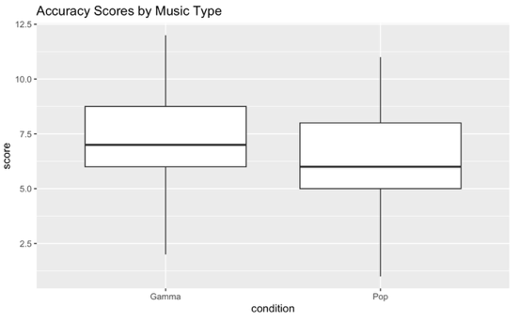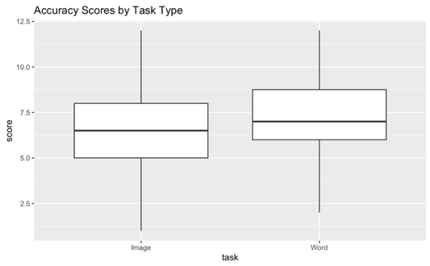
A blocked two-way factorial ANOVA was used to test the differences in mean accuracy scores. The model including the interaction term showed no significant interaction between music type and task type, as shown in Figure 6 and the large p-value of 0.7883. This provided weak evidence of significant interaction between the two factors. In response to this, an additive model between music and task type was fitted instead, testing only the main effects. Its ANOVA table (Figure 7) showed moderate evidence of a difference between the two music conditions (p-value = 0.0622) but weak evidence of a difference between the two memory task types (p-value = 0.3446).

Figure 8. Interaction Plot
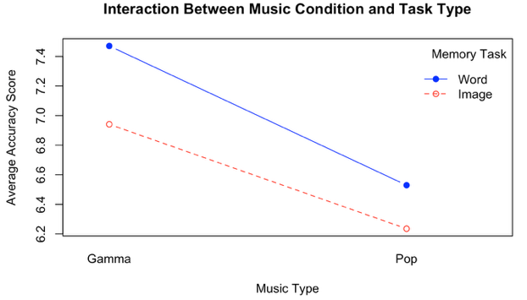
The argument that there was no interaction between music type and memory task was further strengthened by Figure 8. The roughly parallel lines indicated weak evidence of a significant interaction, and across both tasks, the Gamma rays consistently produced slightly higher scores than pop music, and the word-recall task outperformed image-recall under both music conditions.
Conditions for inference were assessed using the additive model. After examining the Normal-QQ plot (Figure 9) and the Fitted Values vs Residuals plot (Figure 10), we concluded the residuals were approximately normal and displayed no clear patterns or fan-shapes when plotted against the fitted values, satisfying the constant variance and normality conditions. Using values from Figure 3, the ratio of the largest standard deviation to the smallest was 1.123, which was less than 2, numerically confirming that the constant variance term was met. Due to the random assignment of the treatment order, the independence condition was also satisfied.

Discussion
Overall, our descriptive statistics found that the Gamma-Word attempts had the highest accuracy scores, and the lowest scores came from the Pop-Image treatment. Although our descriptive statistics suggest that the Gamma rays and word-recall tasks were associated with slightly higher accuracy scores, our ANOVA inferential results provided limited support for these. The interaction between music type and task type was not significant, contrary to our hypothesis. The data provided moderate evidence of a difference between music conditions, which supported our hypothesis, but little evidence of a difference between task types, disproving our prior guess.
This study had several limitations. We used a convenience sample, which was not representative of the entire population of broader students. Because of this, our findings can only be generalized to other college students in similar statistics courses. Participants completed the Google Form at their own pace and were allowed to leave after. Due to this, the testing conditions were not completely controlled, as participants were moving around and causing potential distractions. Future studies would benefit from stricter timing controls and more standardized settings. Additional research could also include a larger, more representative sample and a control group that had no auditory stimuli.
In conclusion, while descriptive patterns hinted at potential benefits of 40-Hz Gamma rays for short-term memory, the statistical evidence was moderate, and a task type showed little effect. The type of background music had the same effect on verbal and visual memory, shown by the weak evidence of an interaction. Although our hypotheses were only partially supported, this study contributes to the growing interest in how the auditory environment influences memory and cognitive performance.

Appendix
Figure 1. Group Means by Music
Condition | Mean | SD
Gamma | 7.206 | 2.280
Pop | 6.382 | 2.450

Figure 2. Group Means by Memory Task
Task | Mean | SD
Image | 6.588 | 2.548
Word | 7.000 | 2.229

Figure 3. Treatment Means by Music Type and Memory Task
Treatment | Mean | SD
Gamma–Image | 6.941 | 2.384
Pop–Image | 6.235 | 2.728
Gamma–Word | 7.471 | 2.211
Pop–Word | 6.529 | 2.211

Figure 6. ANOVA table for Interaction Model
Source | DF | Sums of Squares | Mean Square | F value | Pr > F
Participants | 16 | 211.62 | 13.226 | 4.100 | 7.36e-05
Condition | 1 | 11.53 | 11.529 | 3.574 | 0.0647
Task | 1 | 2.88 | 2.882 | 0.893 | 0.3493
Condition:Task | 1 | 0.24 | 0.235 | 0.073 | 0.7883
Residuals | 48 | 154.85 | 3.226

Figure 7. ANOVA table for Additive Model
Source | DF | Sums of Squares | Mean Square | F value | Pr > F
Participants | 16 | 211.62 | 13.226 | 4.179 | 5.49e-05
Condition | 1 | 11.53 | 11.529 | 3.643 | 0.0622
Task | 1 | 2.88 | 2.882 | 0.911 | 0.3446
Residuals | 49 | 155.09 | 3.165

Figure 9. Residuals vs Fitted Values Plot
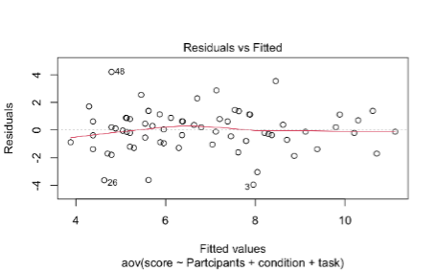
Figure 10. Normal Q-Q Plot
